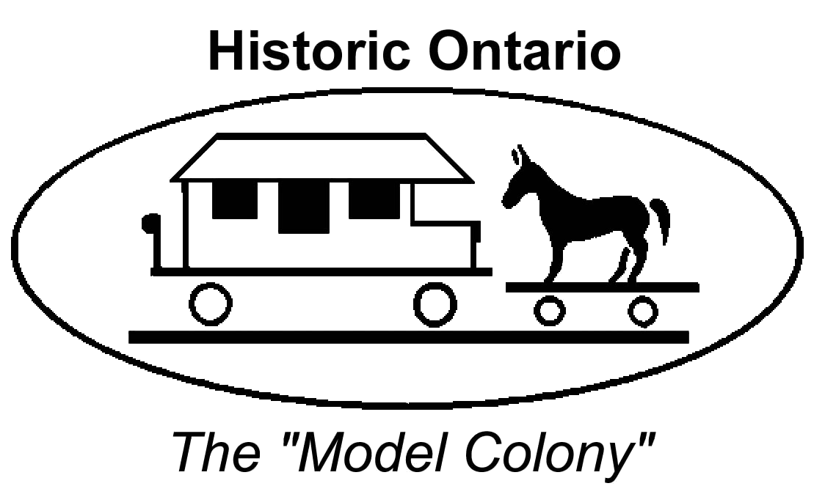

CITY OF ONTARIO

PLANNING COMMISSION
HISTORIC PRESERVATION SUBCOMMITTEE

AGENDA

April 8, 2021

NOTICE OF CANCELLATION

NOTICE is hereby given that the April 8, 2021, regular meeting of the City of Ontario Planning Commission Historic Preservation Subcommittee, which meets at 5:30 PM in the City of Ontario Community Conference Rooms 1 & 2 located at, 303 East “B” Street, Ontario, California, is hereby cancelled, there being no business to come before it.

NOTICE is further given that the next regular meeting of the City of Ontario Planning Commission Historic Preservation Subcommittee will be held on May 13, 2021, at 5:30 PM, in the City of Ontario Community Conference Rooms 1 & 2 located at, 303 East “B” Street, Ontario.

Dated this date: April 5, 2021

HISTORIC PRESERVATION SUB-COMMITTEE

By Gwen Berendsen
Administrative Assistant

