RESIDENTIAL KITCHEN REMODEL REQUIREMENTS
Starting July 1, 2023, all permit applications for the Building Department will be required to be submitted digitally through Citizen Portal Access.
For Digital Submittals Instructions see Information Bulletin 109 on Building Department website under Applications/Forms.

A permit is not required for simple projects that only replace (like-for-like with no changes in layout) for kitchen cabinets, countertops, kitchen appliances and plumbing fixtures, flooring, or refacing of existing cabinets.

Permits and plans are required when kitchen remodel includes alteration to the existing kitchen floor plan configuration, structural changes, adding new or relocating electrical or plumbing fixtures.

BUILDING/RESIDENTIAL CODE REQUIREMENTS

- Kitchen ceiling height shall not be less than 7’-0”.
- Smoke alarms are required in all bedrooms, adjoining halls, and at each floor. Carbon monoxide alarms are required in hallway or immediate area leading to bedrooms and at each floor.
- Kitchen shall have 36” minimum clear passageway between counter fronts and appliances or between counter fronts and walls.

ELECTRICAL CODE REQUIREMENTS

- Receptacles installed to serve the countertop surfaces shall be GFCI protected and tamper-resistant.
- Receptacles shall be provided at all countertop areas that are 12 inches or wider, located no farther than 4 feet apart and no farther than 2 feet from edge of counter. See attached illustration “Kitchen Countertop Receptacles Layout”.
- Receptacles shall be located no more than 20 inches above countertop.
- Islands and peninsula shall have at least one receptacle mounted not more than 12 inches below the countertop and where the countertop not extending more than 6 inches beyond its base.
- Countertop receptacles shall be supplied by a minimum of two 20-amp small appliance branch circuit.
- Dishwasher, garbage disposals, and other built-in appliances (e.g. microwave) require dedicated circuits.
- A dedicated 20-amp circuit is required for cord and plug connected range exhaust hoods.
- Receptacles shall not be installed in a face-up position in countertops.

PLUMBING CODE REQUIREMENTS

- Every gas appliance is required to have an accessible shut off valve in the same room within 3 feet of the appliance.
- Gas appliance connectors shall not extend from one room to another, through any wall, floor, partition, or appliance housing.
- If adding or relocating a gas line, presure test is required.
- The connection between a dishwasher and garbage disposal or drain must have an air gap fiiting installed above the flood rim of the sink.

MECHANICAL CODE REQUIREMENTS

- Kitchen ranges shall have a vertical clearance above the cooking top of not less than 30” to combustible materials or metal cabinets. The minimum clearance may be reduced to 24” when protected by ¼” insulating millboard cover with sheet metal not less than 0.0122” thick.
- Minimum residential kitchen exhaust rates is 100 CFM.
- Exhaust ducts shall terminate outside the building, equipped with a back draft-damper, and shall terminate 3 feet away from any building openings or property line.
- Exhaust ducts must be galvanized steel, stainless steel, or copper and have a smooth interior surfaces (no flexible duct allowed).

ENERGY CODE REQUIREMENTS

- All kitchen luminaires shall be high efficacy and shall have readily accessible wall-mounted dimming controls.
- Recessed downlight luminaires in ceilings shall be listed for zero clearance insulation contact (IC) and labeled airtight (AT) with air leakage less than 2.0 CFM, sealed with a gasket or caulk between the housing and ceiling, shall not contain screw base sockets (E26), comply with JA8 elevated temperature requirements for enclosed or recessed luminaires.
- For alterations of existing ceiling-recessed luminaire with screw-based socket must use new JA8-compliance trim kits or lamps designed for use with recessed downlights or luminaires.

CALGREEN CODE REQUIREMENTS

- Use low VOC content for paints, adhesives, sealants, primers, or caulkings.
- Composite wood products (hardwood plywood, particleboard, and medium density fiberboard) shall meet the requirements for Formaldehyde Limits.

INSPECTIONS:

A rough electrical inspection is required after electrical boxes are installed and before any devices are connected. Any other structural, mechanical, or plumbing alteration must also be scheduled for a rough inspection. Additional inspections may be needed based on extent of the project. Final inspection is required after all the work is completed.

KITCHEN COUNTERTOP RECEPTACLES LAYOUT

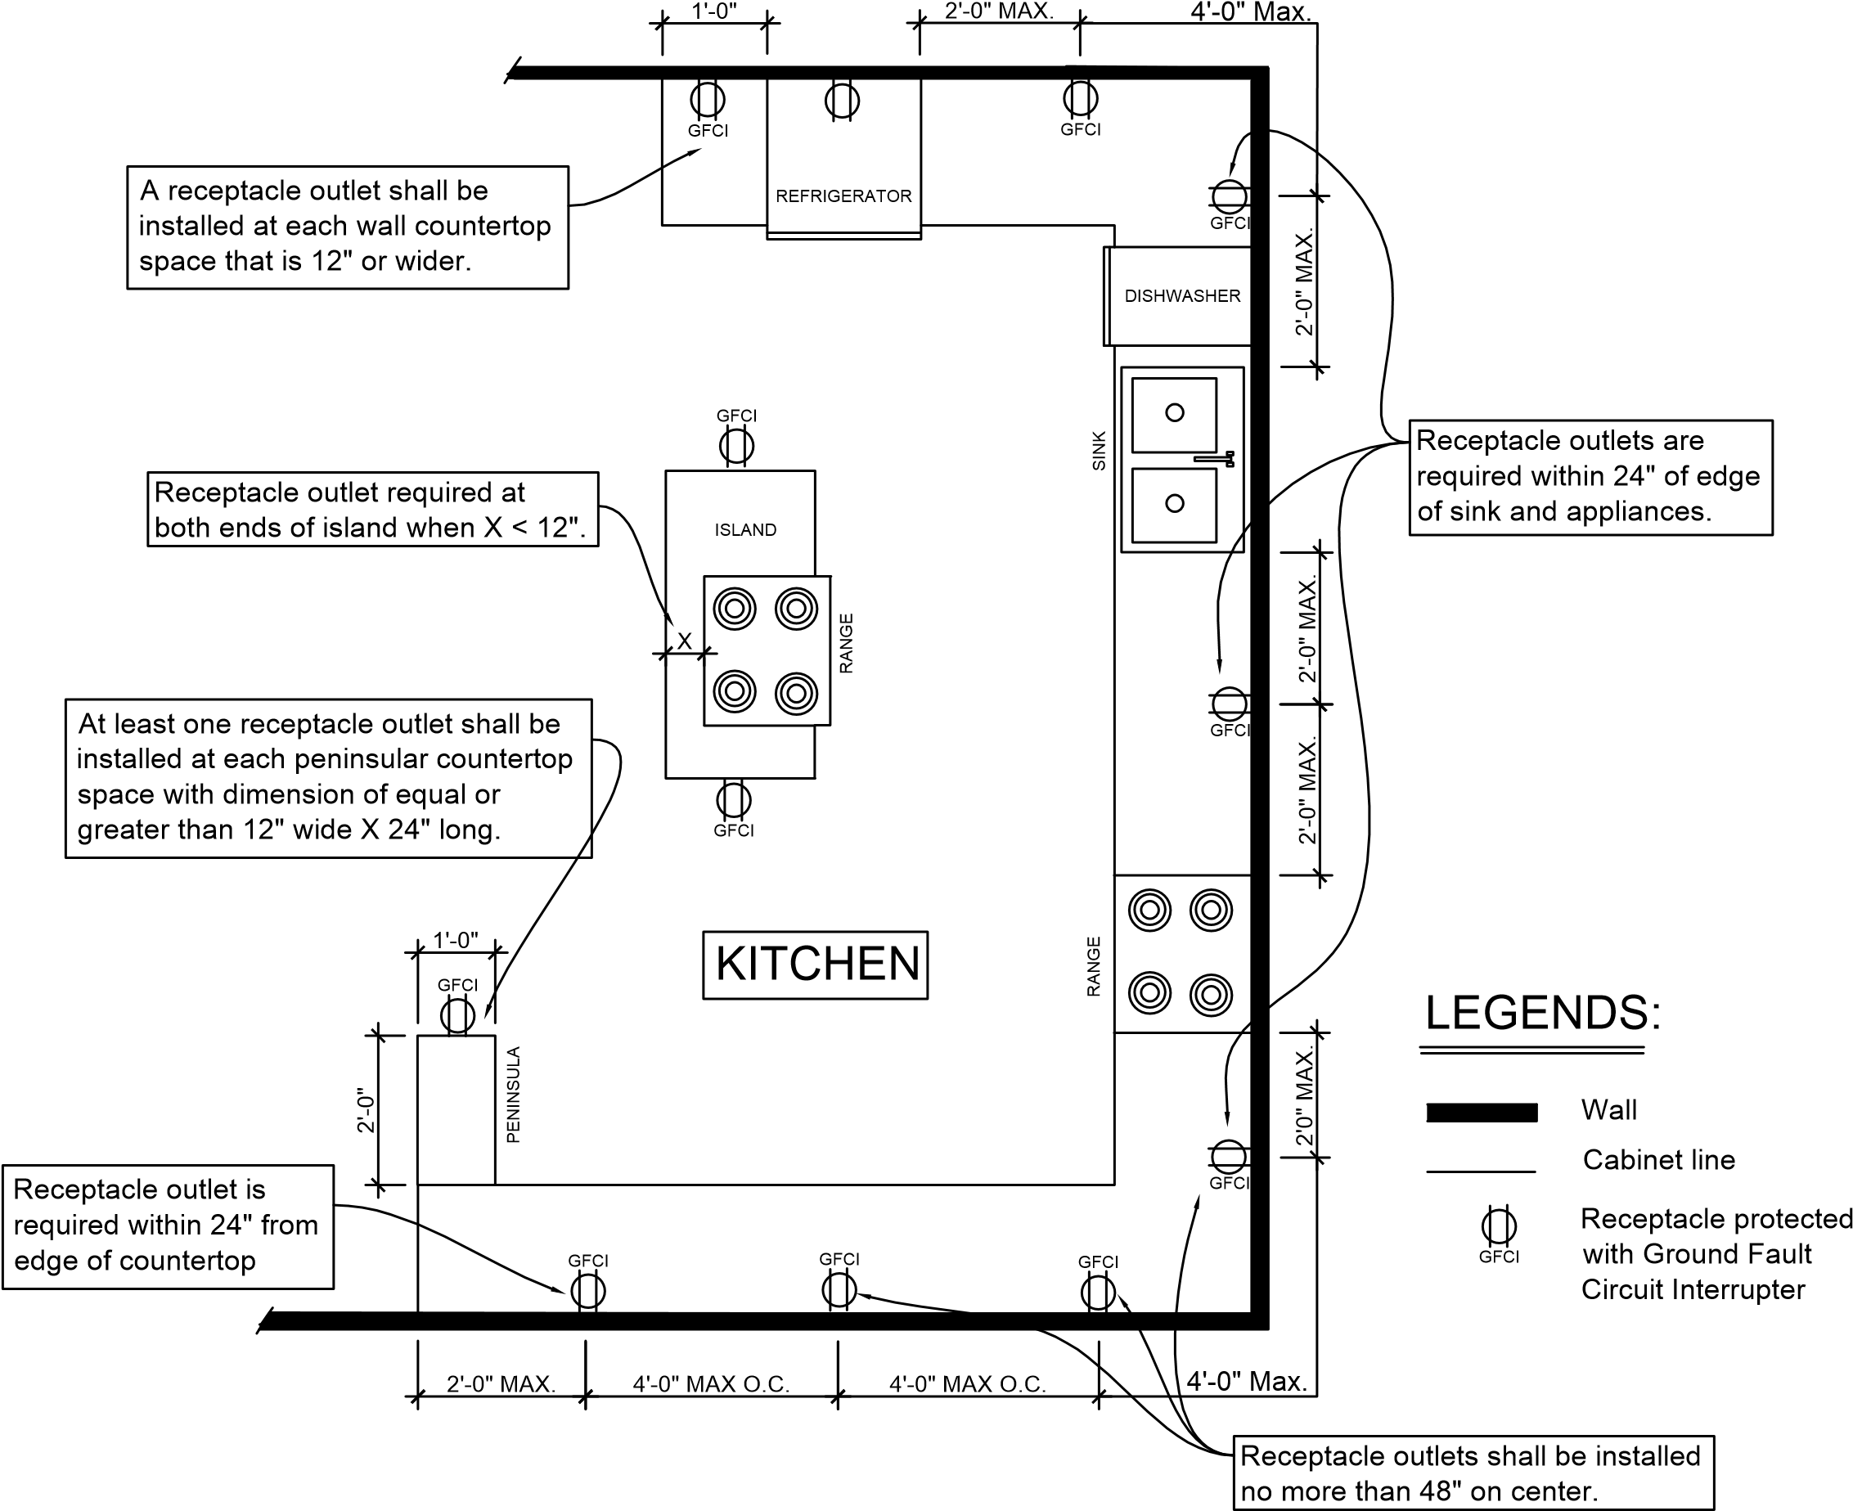

NOTES:
- All countertop receptacles shall be tamper resistant.
- Receptacles shall be located no more than 20” above countertop.


Approved by: James Caro (Building Official Director) Date:
Prepared by: Setiawan Ganda (Senior Plan Check Engineer)

